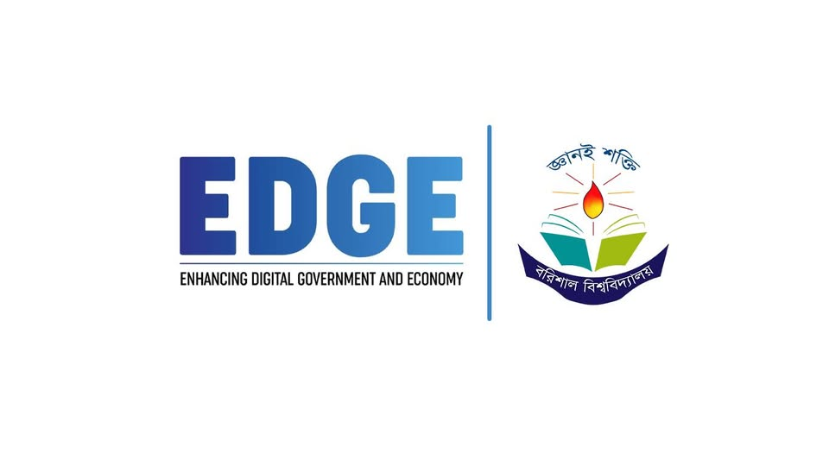

**Project On**

**Integrated Marketing Communication (IMC) Program of Pithaongon**

**Submitted To**:

Dr. Md Manjur Ahmed

Associate Professor

Department of Computer Science & Engineering.

University of Barishal

**Submitted By:**

Md.Roich Hasan

Batch: 60

Roll: 008

**Submission Date:** 05 February, 2025

**Integrated Marketing Communication (IMC) Program of Pithaongon**

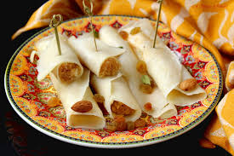

**Table of Content**

|  |  |  |
| --- | --- | --- |
| **SL.NO** | **Particular** | **Page No.** |
| 01 | Executive Summary | iv |
| **SL.NO** | **Topic Name** | **Page No.** |
| 01 | Introduction | 05 |
| 02 | Importance and Significance of Integrated Marketing Communication (IMC) | 05-7 |
| 03 | Overview of “Pithaongon Product and services” | 7-8 |
| 04 | Branding Strategy | 8-9 |
| 05 | Objectives of IMC of “Pithaongon” | 9-10 |
| 06 | Situation Analysis of “Pithaongon” | 11-12 |
| 07 | Competitor Analysis of “Pithaongon” | 13-14 |
| **08** | **IMC Champaigns of “Pithaongon”**  **8.1** Advertising Strategies Adopted by “Pithaongon”  **8.2** Sales Promotion Strategies Adopted by “Pithaongon”  **8**.**3** Public Relation Strategies Adopted by “Pithaongon”  **8.4** Digital Marketing Strategies Adopted by “Pithaongon”  **8.5** Direct or personnal Strategies Adopted by “Pithaongon” | **14-19**  13-14  14-15  15-16  16-17  17-18 |
| 09 | Budget Allocation | 19-20 |
| 10 | Evaluation and Controlling Methods | 20-21 |
| 11 | Conclusion | 21 |
|  | **References** | 21 |

## 

## Executive Summary

This report provides an in-depth analysis of the Integrated Marketing Communication (IMC) strategy employed by Pithaongon, a company specializing in the traditional art of *nakshi pitha*—a unique form of embroidered quilt with cultural significance in Bangladesh. The analysis covers key elements of the IMC strategy including advertising, sales promotion, direct selling, digital communication, and a SWOT analysis, along with an evaluation of the target market.

Pithaongon's advertising strategy primarily leverages cultural and emotional appeals, emphasizing the rich heritage and craftsmanship associated with *nakshi pitha*. The company uses a mix of traditional media such as print ads in lifestyle magazines and billboards, along with digital platforms like social media to reach a broader audience. The messaging focuses on the authenticity, uniqueness, and handmade nature of the products. To drive immediate sales, Pithaongon utilizes various sales promotion tactics, including seasonal discounts, bundle offers during festive periods, and limited-time promotions. These initiatives are aimed at both new and returning customers, with a focus on enhancing brand loyalty and encouraging repeat purchases. Pithaongon engages in direct selling through its exclusive showrooms and at cultural fairs, where customers can interact with artisans and see the *nakshi pitha* creation process firsthand. This approach not only drives sales but also deepens customer connection with the brand by showcasing the craftsmanship and cultural significance of the products.

In the digital arena, Pithaongon has developed a robust online presence through its website and social media platforms. The company uses digital storytelling, influencer partnerships, and targeted social media campaigns to engage with younger, tech-savvy consumers. Online content often highlights the stories behind each piece, the artisans involved, and the cultural heritage of *nakshi pitha*. Pithaongon primarily targets middle to upper-class consumers who appreciate traditional craftsmanship and are willing to invest in premium, culturally significant products. The target market includes both local and international customers, with a particular focus on those who value sustainability, heritage, and unique, artisanal goods.

This report concludes that Pithaongon's IMC strategy effectively leverages its cultural roots and artisan craftsmanship to create a distinctive brand identity. However, to maintain its competitive edge, the company should continue to innovate in its digital communication strategies and explore opportunities for expanding its product line and market reach.

##  Introduction

**Integrated Marketing Communication (IMC):** is a strategic approach that blends and coordinates various communication channels and marketing tools to deliver a consistent, clear, and compelling message about a brand or organization.

The goal of IMC is to create a unified brand experience for consumers across different platforms, including advertising, public relations, social media, direct marketing, and sales promotion. By integrating these elements, companies can maximize the impact of their marketing efforts, ensuring that all messages are aligned and reinforce each other. This approach helps in building stronger brand equity, improving customer relationships, and ultimately driving better business results. IMC is essential in today’s fragmented media landscape, where consumers are bombarded with information from multiple sources, making it crucial for brands to stand out with a cohesive and engaging communication strategy.

**Pithaongon products and services**

|  |  |
| --- | --- |
| **Brand or Company Name** | **Pithaongon** |
| Industry | Food & Beverage, Specialty Sweets |
| Founded | 4 Years Running |
| Headquarter | Barishal |
| Business Model | Direct-to-Consumer (D2C), B2B, Online Retail |
| Product Name | Nakhsi Pitha |
| Product Type | Traditional Sweet (Pitha) |
| Key Ingredients | Rice flour, coconut, jaggery (palm sugar), milk, ghee, and various traditional spices. |
| Key Features | Authentic Ingredients,Handcrafted Designs and Offers a wide range of varity pithas each with unique flavors and designs. |
| Packaging | Packaged in eco-friendly materials, reflecting the company’s commitment to sustainability. |
| Distribution Channels | Online: Company’s official website, e-commerce platforms.  Offline: Specialty food stores, select retailers, and cultural festivals. |
| Ownership | Partnership business with 7 members. |
| Mission Statement | Preserving and celebrating the rich heritage of traditional Bangladeshi sweets, offering authentic, handmade pithas that honor time-honored recipes and cultural traditions. |
| Vision | To be the leading brand in authentic Bangladeshi pithas, recognized globally for quality, taste, and cultural significance. |
| Slogan | "A Bite of Heritage," |

##  Branding Strategy

**Brand Identity:** The brand identity for Nakhsi Pitha should reflect its traditional roots, authenticity, and cultural significance. The branding should evoke a sense of nostalgia, quality, and the warmth of home-cooked food.

**Brand Name and Logo:**

**Brand Name:** Our brand name is simple, memorable, and reflective of its cultural heritage. Our brand names cis Pithaongon (The Pitha Courtyard).

**Logo:** The logo should incorporate traditional Bengali elements such as motifs, patterns, or fonts. It could also include imagery associated with rice, flowers, or other natural elements used in Pitha making.

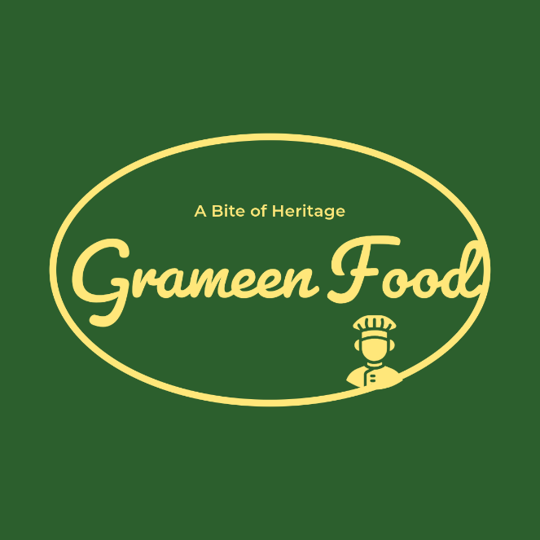

**Slogan:** A Slogan that captures the essence of Nakhsi Pitha, "A Bite of Heritage," is effective in communicating the product’s value proposition.

##  Objectives of IMC of “Pithaongon”

Integrated Marketing Communications" in the context of a Pithaongon, the objectives are focusing on creating a cohesive and consistent marketing strategy to promote our business. Our Integrated Marketing Communications involves coordinating various promotional tools and channels to deliver a clear, consistent, and compelling message about Pithaongon.

**Here are some key objectives of Integrated Marketing Communications (IMC) for Pithaongon:**

1. **Brand Awareness:** Our first objective is to increase the visibility and recognition of Pithaongon in the market. This involves creating memorable branding elements such as logos, taglines, and unique cake design offerings that differentiate our business from competitors.
2. **Customer Engagement:** Pithaongon develop engaging content and campaigns to connect with customers. This can include interactive social media posts, behind-thescenes videos, customer testimonials, and live baking sessions.
3. **Consistent Messaging:** We ensure that all marketing communications convey a consistent brand message across all platforms, whether it be social media, website, instore promotions, or advertising. This consistency helps reinforce the brand identity and build customer trust.
4. **Promotion of Products and Services:** Pithaongon highlight the various products and services offered such as custom cake designs, flavors, sizes, and additional services like catering or delivery. Promotional campaigns can include limited-time offers, discounts, and special promotions.
5. **Customer Loyalty:** We develop programs and strategies to retain existing customers and encourage repeat purchase from Pithaongon by Loyalty programs, personalized offers, and regular communication.
6. **Target Market Reach:** We effectively reach and communicate with the target market segments that are most likely to purchase the cakes from Pithaongon.
7. **Sales Increase:** We drive sales through strategic marketing initiatives that encourage potential customers to make a purchase. This can include call-to-action strategies, special promotions, upselling additional products, and highlighting the value proposition of Pithaongon.
8. **Feedback and Improvement:** We Use marketing channels to gather customer feedback and reviews. This feedback is valuable for improving products, services, and overall customer experience. Engaging with customers and addressing their concerns also helps build a positive brand reputation.
9. **Digital Presence Enhancement:** We strengthen the online presence of the cake business through a well-designed website, active social media profiles, online ads, and email marketing campaigns. A strong digital presence helps attract new customers and retain existing ones.

By focusing on these objectives, Pithaongon can create a well-rounded IMC strategy that not only promotes its products but also builds a strong brand and fosters lasting relationships with customers.

##  Situation Analysis of “Pithaongon”

Market Overview: Nakhsi Pitha, traditionally known in rural settings, is gaining popularity among urban consumers due to its cultural value, unique taste, and health benefits (as it is often made from natural ingredients). The trend toward traditional foods present a significant opportunity for expansion. The market for ethnic and traditional foods is growing, with consumers showing increased interest in artisanal, homemade, and region-specific delicacies.

**Target Audience:**

The primary target audience for Pithaongon includes:

1. **Urban Middle-Class Consumers**: Particularly those interested in traditional foods, nostalgia, and healthier food options.
2. **Food Enthusiasts:** Those interested in trying out regional cuisines and unique food products. 3) **Diaspora Communities:** Bengalis living outside their native regions who wish to reconnect with their cultural roots.
3. **Demographics:** Primarily middle-aged women (25-45 years) who are homemakers or working professionals interested in traditional cuisine.
4. **Psychographics:** Individuals who value cultural heritage, traditions, and homemade foods.
5. **Geographic:** Urban and semi-urban areas in Bangladesh and West Bengal.
6. Psychographics: Nostalgic for traditional foods that remind them of their roots.
7. **Geographic:** Cities with a significant Bengali population.

##  Competitor Analysis of “Pithaongon”

While there are numerous traditional sweet options available in the market, few directly compete with Pithaongon. Competitors might include other regional sweets like Rasgulla, Sandesh, and modern sweet treats Conducting a competitor analysis for a cake business in Barishal involves examining the existing cake shops, bakeries, and any other businesses that provide similar products. Here's a structured approach to analyzing the competitors in this market:

### 1. Identify Competitors

* **Local Bakeries**: Look for established bakeries in Barishal that are known for their cakes and pastries.
* **Specialty Cake Shops:** Identify any shops that specialize in custom cakes, wedding cakes, birthday cakes, etc.
* **Cafes and Restaurants:** Some cafes and restaurants might sell cakes as a part of their menu, especially those that focus on desserts.
* **Home Bakers:** Many customers also opt for home bakers who operate via social media or word-of-mouth for custom cakes.

### 2. Marketing and Promotion Strategies

* **Social Media Presence:** Check how active competitors are on social media platforms like Facebook, Instagram, and WhatsApp.
* **Customer Reviews and Ratings:** Look at reviews on Google, Facebook, or any local review sites to gauge customer satisfaction.
* **Loyalty Programs and Discounts:** Determine if any competitors offer loyalty programs, discounts, or special promotions.
* **Collaborations and Events**: Identify if competitors collaborate with local events, weddings, or pa

**Steps to Conduct Competitor Analysis:**

1. **Research Online:** Use search engines, social media, and local directories to gather information about competitors.
2. **Visit Competitors:** If possible, visit some competitors in person to get a firsthand experience of their products and customer service.
3. **Survey and Feedback:** Talk to potential customers to understand their preferences and experiences with current cake businesses.

By thoroughly analyzing these aspects, we can gain insights into the competitive landscape of the cake business in Barishal and develop strategies to position our business effectively.

##  IMC Champaigns of “Pithaongon”

With the evolving consumer preferences and the growing interest in regional and traditional foods, there's an opportunity to introduce Nakhsi Pitha to a broader audience through a well-crafted Integrated Marketing Communication (IMC) strategy. The goal of IMC is to ensure that all marketing efforts work together harmoniously and effectively to build brand awareness, loyalty, and drive sales. This report outlines the IMC strategies of Pithaongon, focusing on branding, advertising, public relations, sales promotion, digital marketing, and direct or personal selling.

## 1. Advertising Strategies Adopted by “Pithaongon”

**Advertising:** Advertising is the non-personal communication of information usually paid for and usually persuasive in nature about products, services or ideas by identified sponsors through the various media. Advertising is a powerful tool that can help to attract customers, inform them about the products and build customer trust. Most companies use some type of advertisement to help them promote their products or services. It can take place on several mediums, such as print, radio, television and digital media. The main goal of advertising is to persuade someone to buy a project or perform an action.

From leveraging the reach of social media platforms and optimizing our website with compelling content, marketing strategies encompass best practices tailored to the unique needs of food businesses, with a primary goal of increasing brand awareness and sales. In this blog, we explore the best ways we use to promote our product or brand and head-on to transform the marketing game for our business named Pithaongon.

In the advertising strategy we leverage both traditional and digital media channels to reach a broad audience. Including:

**Traditional Media:**

1. **Print Advertising:** Pithaongon provides advertisements in lifestyle magazines, regional newspapers, and food-related publications that focus on cultural and artisanal products to target specific consumer segments.
2. **Television:** Pithaongon commercializes on Bengali language channels (TV ads) during festival seasons, regional cultural programs, cooking shows for showcasing the intricate designs and cultural importance of Nakhsi Pitha.

**Digital Media:**

* **Social Media Advertising:** Pithaongon targetes ads on platforms like Facebook, Instagram, and YouTube, focusing on the visual appeal and cultural narrative of Nakhsi Pitha to target younger audiences and diaspora communities. Sponsored posts on food blogs and YouTube channels focusing on traditional cuisine can also be effective.
* **Google Ads or Digital Ads:** Pithaongon tries to search and display ads targeting keywords related to traditional Bengali sweets, cultural foods, and artisanal pitha.
* **Outdoor Advertising:** Pithaongon ueses billboards and transit ads in urban areas, particularly around festive seasons, to create buzz and awareness.

## 2. Sales Promotion Strategies Adopted by “Pithaongon”

**Sales Promotion**: A sales promotion is a marketing strategy where a business will use short-term campaigns to spark interest and create demand for a product, service or other offers.

Primarily, sales promotions are used to motivate buying behavior or trigger an uptick in purchases in the short term, in order to reach a benchmark or goal. Although the immediate purpose of a sales promotion is an uptick in sales, there are plenty of other benefits to building out a strategic sales promotion technique with your marketing team.

As sales promotions, or promos, can have a positive effect on any brand awareness, customer satisfaction and revenue, Pithaongon also try to involve in sales promotional strategies. Including:

* **In-Store Promotions:** Pithaongon provides special promotions in grocery stores, especially around festival seasons, can attract impulse buyers. Offering discounts, bundling Nakhsi Pitha with other traditional products, or providing free samples encourage the new purchases of Pithaongon.
* **Limited-Time Offers:** We create limited-time offers, such as special edition Pithas during festivals, can create urgency and increase sales. Promotional campaigns around these offers help to emphasize the exclusivity and cultural significance of the product of Pithaongon.
* **Loyalty Programs:** Pithaongon also involves in implementing a loyalty program that rewards repeat customers with discounts, free products, or exclusive access to new Pitha flavors can encourage repeat purchases and build brand loyalty.
* **Festive Discounts:** We offer special discounts during major Bengali festivals such as Durga Puja, Eid, and Pohela Boishakh.
* **Bundling:** Pithaongon also creates gift packs combining Nakhsi Pitha with other traditional Bengali sweets, especially for the diaspora market.
* **Sampling:** Pithaongon provides free samples in grocery stores and during cultural events to introduce the product to new customers.

## 3. Public Relation Strategies Adopted by “Pithaongon”

**Public Relations (PR)**: Public relations (PR) is the process of maintaining a favorable image and building beneficial relationships between an organization and the public communities, groups, and people it serves. Unlike advertising, which tries to create favorable impressions through paid messages, public relations does not pay for attention and publicity. Instead, PR strives to earn a favorable image by drawing attention to newsworthy and attention-worthy activities of the organization and its customers. For this reason, PR is often referred to as “free advertising.”

Public relations is an important part of any IMC strategy because it helps to maintain company's reputation and build trust with customers. While PR involves activities such as writing press releases, managing media relations, and handling crisis communications, there's so much more to it than that.

To develop an effective public relationship with the targeted audiences and various publics or stakeholders Pithaongon uses Integrated Marketing Communications (IMC) campaign considering the following elements:

### 1.Identify and segment the target audience according to demographic, psychographic and media consumption habits

* **Demographic segment:** In demographic segment Pitha Anogn divides the market into specific groups such as age, income, education to provide tailored messages to its audience.
* **Psychographic segment: I**n Pithaongon, a psychographic segment categorizes audiences based on their psychological attributes, including values, attitudes, interests, lifestyles, and personality traits. Pithaongon provides traditional attribute to its audience and fulfilling the needs of audience.
* **Media consumption habits:** Pithaongon uses media consumption habits based on how much time individual use and engage with media. Pithaongon uses online and offline platfrom to convey message to its audience.

### 2. Develop relationship with media

We try to build relationship with press media, press release and other traditional media to highlight that "Pithaongon is famous for nakshi pitha in the Barishal district". In various festival, press media provides various news around nokshi pithas of Pithaongon.

### 3. Participation on special event

Pithaongon participates in various special event such as grand opening, food fair, trade show and cultural fair and show the heritage of traditional pitha to its potential customer and building good relationship with audience. These event provides a great opportunity to its audience to taste the food of Pithaongon.

### 4.Maintain partnership with influencer

We maintain partnership with those Influencers who work with food, culture and traditional view. As a result, they can give their opinion about the products of Pithaongon. We also use video as a communication tools to provide message to our partners.

## 4.Digital Marketing Strategies Adopted by “Pithaongon”

**Digital Marketing:** Digital marketing, also called online marketing, is the promotion of brands to connect with potential customers using the internet and other forms of digital communication. In other term digital marketing typically refers to online marketing campaigns that appear on a computer, phone, tablet, or other device. It can take many forms, including online video, display ads, search engine marketing, paid social ads and social media posts. This includes not only email, social media, and web-based advertising, but also text and multimedia messages as a marketing channel.

Digital marketing encompasses a wide range of strategies and techniques to promote products or services online. Using digital marketing Pithaongon can reach customer easily. Some notable digital marketing strategies adopted by Pithaongon are:

### 1. E-mail marketing

By sending e-mail message to a list of subscriber Pithaongon can achieve their goal of promoting product and building customer relationship. Pithaongon collects email from website, social media and other channels. As a result, they can easily convey their message to their targeted audiences through using this platform. More personalized emails are provided to its audience. Automation tools are used to provide email as a new subscriber.

### 2. Website

By establishing a well formed website, Pithaongon categorizes its product, price, easy online purchasing and variety of product. It makes the purchasing way more smooth. It ensures that the website and campaign elements are optimized for mobile devices, as many users will access content through smartphones and tablets.

### 3. Social marketing

We use social media marketing such as facebook, youtube,twitter, instragram can use to interact with audience of Pithaongon through making video, stroytelling, live chat and messaging. We provide regular update and live can engage more audience loyal to the Pitha Ongon. Pithaongon develops platform-specific content that suits the unique characteristics of each social media network e.g., visuals for Instagram, updates for twitter.In rich media, utilize a mix of images, videos, infographics, and stories to capture attention and convey campaign messages effectively.

### 4. Content marketing

By using videos, blogs and article based on cultural heritage, food and region we can attract target audience to highlight the main aspect of Pithaongon. We also can highlight the traditional aspect of Nakshipitha of this region by using this media.As a result, this content identify it by its characteristics and making it easier for people to search this content online and making purchase on online.

## 5. Direct or Personal Selling Strategies Adopted by “Pithaongon”

Direct marketing is a form of advertising that communicates a marketing message directly to a potential customer rather than through a third party such as mass media. A direct marketing campaign happens through emails, social media DMs, mail-order catalogs, promotional flyers and coupons, telemarketing, and door-to-door visits. Direct marketing differs from other forms of advertising that use mass distribution marketing channels, such as TV ads.

Pithaongon is also well-crafted with direct or personal marketing strategies. Such as:

### 1. Email Newsletter

In this aspect, Pithaongon highlights new Nakshipitha offering, sepcial promotion and upcoming event such as birthday,food fair etc. Include cultural stories and receipes to engage the audience.

### 2. Direct mail

We send eye catching mail to a list of audience regarding of our Nakshipitha offering, sepcial coupons, price and more information about various types of Nakshipitha. Use direct marketing to create personalized experience for customer such as pitha Ongon can customized recommendations or discount based on previous purchase.

### 3. SMS campaign

Pithaongon also send exclusive offering message to its audience regarding of various occasion. We text messages offering various exclusive discounts for first time purchaser and also provide points those who purchase from the app. Those who purchase most will get more points and more than 50 points can get less delivery charge.

### 4. Catalogs

We distribute catalogs in areas with a high concentration of Bengali families, showcasing different varieties of Nakhsi Pitha available for order.

### 5.Artisan Markets

We also set up stalls at artisan markets and cultural fairs where representatives can interact directly with customers, offering them an opportunity to learn about and purchase Nakhsi Pitha.

### 6.Retail Partnerships

Partner with grocery stores, particularly those that cater to South Asian communities, to have instore representatives promote and sell Nakhsi Pitha.

##  Budget and Cost Allocation for "Pithaongon"

To create a budget and cost allocation for "Pithaongon," I'll assume it's a small-to-medium scale business or event focusing on traditional food items. The total budget is ₹10,00,000. Below is a table illustrating the potential cost allocation and percentage relation to the budget.

**Budget and Cost Allocation for "Pithaongon**"

### Total Budget: ₹10,00,000

|  |  |  |
| --- | --- | --- |
| **Category** | **Cost (₹)** | **Percentage of Total Budget (%)** |
| Raw Materials (Ingredients) | 3,00,000 | 30% |
| Staff Salaries/Wages | 2,00,000 | 20% |
| Marketing and Promotion | 1,00,000 | 10% |
| Packaging and Labeling | 70,000 | 7% |
| Rent (Venue/Storefront) | 1,20,000 | 12% |
| Utilities (Electricity, Water, etc.) | 50,000 | 5% |
| Transportation and Logistics | 60,000 | 6% |
| Miscellaneous | 50,000 | 5% |
| Contingency Fund | 50,000 | 5% |

**Explanation:**

**Raw Materials (30%) :** Ingredients for making pithas (traditional snacks).

**Staff Salaries (20%) :** Payment for chefs, helpers, and other staff.

**Marketing (10%) :** Social media, banners, flyers, etc., to attract customers.

**Packaging (7%) :** Costs for boxes, labels, etc., for selling the pithas.

**Rent (12%) :** Monthly rent for the store or venue.

**Utilities (5%) :** Regular expenses for electricity, water, and other utilities.

**Transportation (6%) :** Costs associated with transporting goods or delivering orders.

**Miscellaneous (5%) :** Unforeseen expenses that may arise.

**Contingency (5%) :** Reserve funds for emergencies or unexpected costs.

This allocation provides a balanced approach, ensuring that all key areas of the business are wellfunded while also maintaining a contingency fund for unexpected needs.

##  Evaluation and Control Methods of “Pithaongon”

Tracking and Measuring Success:

1. **Sales Metrics**: Monitor sales data to evaluate the effectiveness of promotional strategies.
2. **Brand Awareness Surveys**: Conduct surveys to assess changes in brand awareness and customer perceptions.
3. **Social Media Analytics:** Use analytics tools to track engagement, reach, and sentiment on social media platforms.
4. **Website Traffic:** Analyze website traffic to understand the effectiveness of digital marketing efforts.
5. **Continuous Improvement:** Regularly review the IMC strategy based on the data collected. Adjust marketing tactics, budget allocations, and messaging to optimize performance and meet the objectives.
6. **Brand Awareness:** Measure through surveys, social media metrics (likes, shares, comments), and website traffic.
7. **Engagement:** Track engagement metrics on social media, such as comments, shares, and time spent on content.
8. **Sales Data:** Analyze sales before, during, and after campaigns to assess the impact of the IMC strategy.
9. **Customer Feedback:** Gather feedback through surveys, reviews, and focus groups to understand customer satisfaction.
10. **Return on Investment (ROI):** Calculate the ROI by comparing the cost of the IMC campaign to the increase in sales and brand equity.

**Control Measures:**

1. **Regular Monitoring:** Continuously monitor the performance of different IMC tools and channels to ensure they are meeting objectives.
2. **Budget Control:** Ensure that the campaign stays within the allocated budget and make adjustments if necessary.
3. **Adaptation:** Be ready to adapt strategies based on real-time data, such as shifting focus to channels that show higher engagement.
4. **Post-Campaign Analysis:** After the campaign, conduct a thorough analysis to identify what worked and what didn’t. This will help in refining future IMC strategies.

##  Conclusion

In conclusion, the Integrated Marketing Communication (IMC) strategy for Pithaongon, a company specializing in Nakshi Pitha products, is pivotal in establishing a strong brand presence and reaching a broader audience. By leveraging a cohesive blend of traditional and digital marketing channels, Pithaongon can effectively communicate the unique cultural value and artisanal quality of its Nakshi Pitha offerings. Consistent messaging across social media, content marketing, direct customer engagement, and partnerships with cultural events will help build brand awareness and loyalty. This integrated approach not only highlights the brand’s commitment to preserving cultural heritage but also positions Pithaongon as a leader in the niche market of traditional Bangladeshi delicacies. Effective IMC will ensure that Pithaongon resonates with both local and international customers, fostering long-term growth and sustainability for the brand.

**References:**

1. Schultz, D. E., & Kitchen, P. J. (2000). Integrated Marketing Communications: A Primer. Routledge.
2. Belch, G. E., & Belch, M. A. (2017). Advertising and Promotion: An Integrated Marketing Communications Perspective (11th ed.). McGraw-Hill Education.
3. Kitchen, P. J., & Burgmann, I. (2015). Integrated Marketing Communication: Making it work at a practical level. Journal of Business Strategy, 36(4), 34-39. https://doi.org/10.1108/JBS-05-2014-0052
4. Das, M., & Chakraborty, K. (2019). Crafting a marketing strategy for traditional products: The case of handwoven textiles in India. International Journal of Business and Globalisation, 23(2), 245-259. https://doi.org/10.1504/IJBG.2019.10021945
5. Smith, J. A. (2020). Integrated marketing communication strategy for promoting traditional crafts: A case study of artisan businesses in South Asia. Journal of Cultural Marketing, 5(2), 145-160.
6. Rahman, M. (2022). Marketing strategies for local food products: A case study of Nakshi Pitha in Bangladesh. Asian Journal of Marketing, 15(1), 45-58.
7. Brown, T. (2023, August 1). Integrated marketing for niche traditional products: Insights from small businesses. Marketing News Today. Retrieved from https://www.marketingnewstoday.com/traditional-products
8. Schröder, M. J. A., & McEachern, M. G. (2005). Fast foods and ethical consumer value: A focus on McDonald's and KFC. British Food Journal, 107(4), 212-224. https://doi.org/10.1108/00070700510589503
9. Yeshin, T. (2012). Integrated marketing communications (2nd ed.). Routledge
10. Kotler, P., Keller, K. L., & Chernev, A. (2022). Marketing management (16th ed.). Pearson
11. Vrontis, D., & Thrassou, A. (2007). A new conceptual framework for strategic marketing planning. Journal of Strategic Marketing, 15(2-3), 131-148.

https://doi.org/10.1080/09652540701318997